History 694: Digital Public History
Comparative Site Review
Dr. Kelly

2/5/2020
Chester Pelsang

United States Holocaust Museum:
Americans and the Holocaust Exhibition Review

This is a site review of the temporary exhibit within the United States Holocaust Memorial Museum titled Americans and the Holocaust. The purpose of this review is to better understand how this exhibit was curated for an in-person experience as compared to an online experience. That being said, there are three main sections to this review: the first examines the in person exhibition. Using notes and photographs taken during a visit, this first section is designed to more fully flesh out the exhibition’s primary historical argument, audience, space layout, interactive elements, and much more. The second section is similar to the first in that it questions the exhibition’s digital design, layout, audience interaction, and presentation of the historical narrative, while also providing comparative commentary of the two exhibition mediums. The third and final section of this work draws out one major similarity and one difference that are, perhaps, the most important when comparing these two exhibition platforms and experiences.
Part I: In-Person Experience
Although this online and in-person exhibition is currently open to all who want to partake, a majority of the historical argumentation is directed to American citizens often found in school groups. When the author visited this exhibition, a vast majority of viewers were high school age students who, perhaps, were taking a structured learning fieldtrip.
Therefore, the argument that is told within this exhibit is that, in many cases, Americans did not fully realize or understand the atrocities of the early holocaustic actions of the Nazi party, and in their neglect, America played a role in allowing the Holocaust to spread and fester. This exhibition argument is fully typed on the walls of the entrance stating: “The United States alone could not have prevented the Holocaust, but more could have been done to save the six million Jews who were killed.”
This argument is supported by a thread of print media, polling data, and migrate numbers. In many cases, the exhibition relays heavily on the print media of early twentieth-century America. Throughout the exhibition, one is ushered through a chronological retelling as to how Hitler was portrayed in the US media. The first block of objects are early 1930s Time Magazine covers showing praise for Hitler and his socialist policies. As one continues throughout the exhibit, it is clear that the curators wanted to show changing American sentiment towards Hitler. This information was a on a “public opinion poll” display panel citing statistics from the American Institute of Public Opinion. In fact, many of these public poll panels were expertly positioned to not only show a change in public opinion, but to demarcate when the visitor transitioned from one year to the next in the chronological timeline of the Holocaust.
On that same line of questioning, the layout of the exhibition was masterfully done. The visitors moved through this very structured exhibition in a linear, singular fashion. Meaning, the exhibition goers were funneled through the site in a singular motion as to better understand the chronologically structured exhibition.
Site visitors are also encouraged to interact with touchscreen panels positioned throughout the exhibition. These touch panels offer the visitor access to more print media and digital documents pertaining to American sentiment of Nazi Germany. When one enters the exhibition, one is confronted with a large tv panel in which one could chose a state to see more newspapers that published on the topic of the Nazi party and German Jews. This interactive panel allowed visitors to see what was printed in their hometown newspapers; however, visitors were not able to add their own commentary to these digitized newspapers. In some case, a way to add more interactivity with the site could have been to allow visitors to type out memories of Nazi perceptions from their parents or grandparents.
Part II: Comparative Online Experience
Similar to the in person exhibition, the online display presents a similar argument that during the rise of Nazism, Americas were underinformed or unwilling to intercede in European affairs, and it was through this lack of response that led to massive Jewish casualties. Moreover, the online exhibit asserts this argument with the help of digitized print media sources. One is able to select a news article and then zoom-in to read the sources. This type of source base was common in the in-person experience as well, adding to the exhibit’s scholarly nature.
In many cases, these sources are a mixture of personal letters and printed news media. As one continues throughout the online exhibit, one is directed to scanned images of letters and official State Department memos. These types of sources help the exhibit speak with more authority. In other words, the online exhibit, as with the in-person experience, quotes and cites sources as any historical scholar would when writing research.
Other sources on the website are various videos that are narrated to show a story of American protests in response to Nazism, American newspapers, and American culture during this time. In the fact, these informative videos are the same in both the online and in person exhibitions. Moreover, the online viewing of the videos is much more enjoyable than in person. One is able to pause the video and read the subtitles more clearly, this offers the visitor more control over his or her experience.
Regrading online experience, the user is directed linearly through the exhibit. A “Next” button appears at the bottom of the page indicating more content. The user is then directed through the material chronologically. One is able to use a side menu for more navigation. This side menu shows dots, and these dots display a color to indicate where one is within the larger online exhibition. This form of navigation is well-done due in-part to the navigational dots. One is also able to hover over the dots to see the main themes of the exhibition, and then one can click to be transported to the selected theme or section.
Users also have the opportunity to provide feedback to the curators of the exhibit. This feedback button moves users to a Google Docs page in which one can provide commentary on the site experience. Although this is not a major part of the site, meaning visitors are not pressured to provide feedback, the feedback option does show the curators’ commitment to public engagement and public history.
Part III: Argumentative Theme and Feedback
Regarding historical argumentation, both sites argue that there was a disconnect between American perceptions of the early Nazi rule and the realities of the situation. In many ways, this exhibition, whether the experience was online or in-person, pushes the visitor to consider how Americans received their news and if they questioned headlines. In many cases the purpose of this exhibit was to slide visitors out of their comfort zone, making them think critically about print media in the age of the Holocaust. This aura of uneasiness was felt even with the online experience. The colors and videos presented on the website offer a solemn feeling.
However, the visitor experience did not stop with well-curated color schemes. Both the online and in person exhibition offered visitors interactive modules. The exhibit was designed heavily around printed newspapers, magazines, typed government memos, and transcripts from radio newscasts, but the exhibit offered an opportunity of choice. One was able to choose which printed sources he or she wanted to view. The opportunity was offered online by picking a newspaper of interest, and, in-person, one was able to select newspapers from a large touchscreen map. Choosing a news source, in mays, is an opportunity for investigation and analysis. The exhibit wants its visitors to think critically by comparing various news publishers from various states. In other words, this is not a passive exhibit, one is an active participant in this endeavor to uncover American perceptions of Nazi Germany.
Although both the online and in-person exhibitions are very similar in their message, theme, mood, source base, and linear presentation, they do have differences when it comes to audience feedback. The online platform offers the visitors an opportunity to provide feedback on the overall exhibition experience. One is then able to fill out a Google form to provide commentary on the exhibit. Moreover, this feedback form also collects general age data. Simply, the curators use this form to not only allow visitors to provide feedback, but, in return, the curators also collect limited demographic data. Furthermore, the in-person experience only provides visitors the opportunity to write down what they learned in a notebook at the end of the exhibition tour.

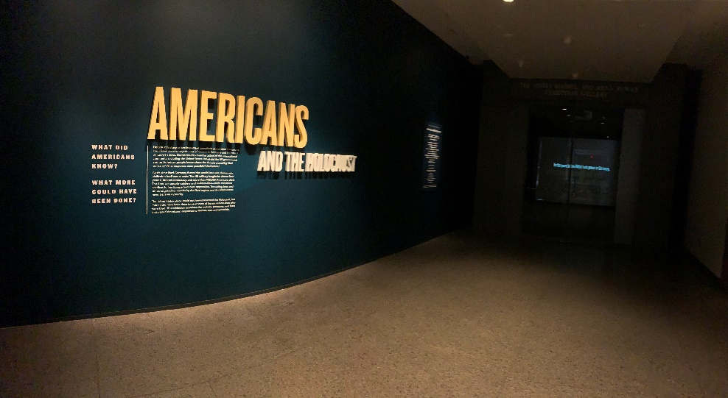
Appendix

Picture taken by author. Entrance Introduction.
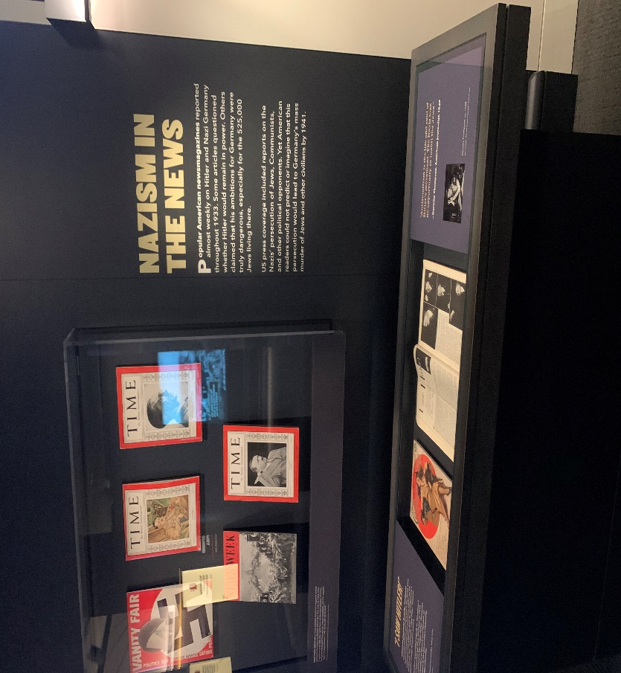

Picture taken by author. First panel of Time Magazine newspapers

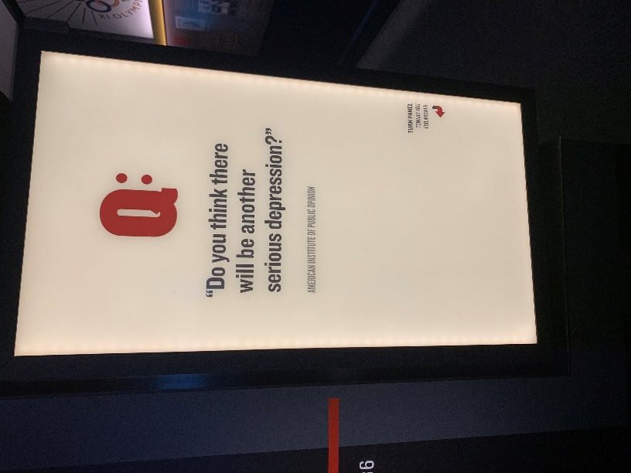

Picture taken by author. Public Polling.

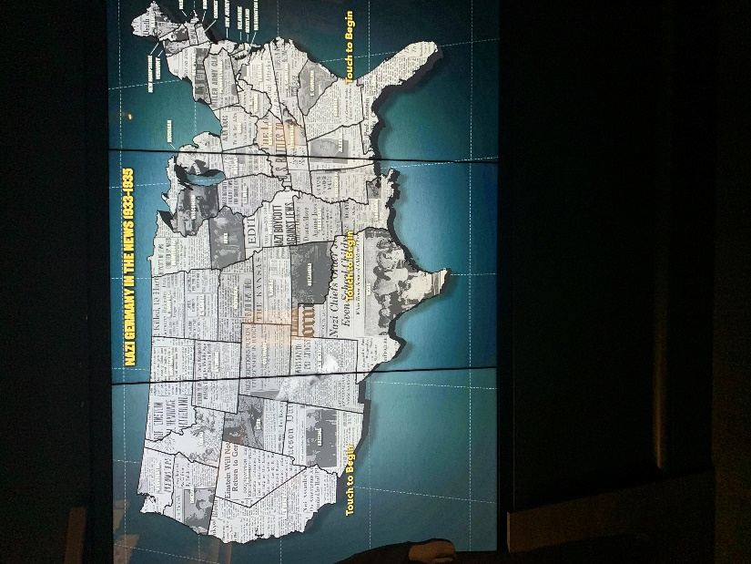

Picture taken by author. Map of news.

Front page of Holocaust online exhibition. Notice the Feedback button on the lower-right corner.
“Americans - United States Holocaust Memorial Museum.” Accessed February 4, 2020. https://exhibitions.ushmm.org/americans-and-the-holocaust/main.

Bibliography

“Americans - United States Holocaust Memorial Museum.” Accessed February 4, 2020. https://exhibitions.ushmm.org/americans-and-the-holocaust/main.

Pelsang, Chester. Americans and the Holocaust. Entrance Introduction, First Panel, Opinion Poll, and Map of News. United States Holocaust Memorial Museum: Washington, D.C., 2020.

See Appendix for: Chester Pelsang, Americans and the Holocaust, Entrance Introduction, United States Holocaust Memorial Museum: Washington, D.C., 2020.
See Appendix for: Chester Pelsang, Americans and the Holocaust, First Panel of Time Magazine, United States Holocaust Memorial Museum: Washington, D.C., 2020
Chester Pelsang, Americans and the Holocaust, Opinion Poll, United States Holocaust Memorial Museum: Washington, D.C., 2020
Chester Pelsang, Americans and the Holocaust, Map of News, United States Holocaust Memorial Museum: Washington, D.C., 2020
“Americans - United States Holocaust Memorial Museum,” accessed February 4, 2020, https://exhibitions.ushmm.org/americans-and-the-holocaust/main.
“Americans - United States Holocaust Memorial Museum.” https://docs.google.com/forms/d/e/1FAIpQLScQurTGZRKtA9bzvr2qvJWfT2AyVIGRZ5Y-ihgO7KUPXtMDhQ/viewform.
See Appendix.
See this link for website front page: “Americans - United States Holocaust Memorial Museum,” https://exhibitions.ushmm.org/americans-and-the-holocaust/main.
See Appendix for picture: Chester Pelsang, “Americans - United States Holocaust Memorial Museum.”

